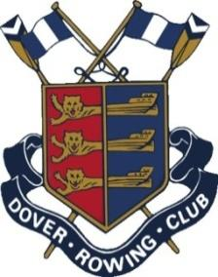
EMERGENCY RESPONSE
Key Steps
Emergency response – Key steps in the event of an emergency or life-threatening injury
- Render assistance
- Call for Help & Emergency Medical Attention:
  - 999 (112)
  - Dover Harbour Police: 01304 216084
  - Dover Harbour Board: 01304 206063

Be prepared to tell 999:
- Who you are, your name and call back number
- Current location of injured person:
Dover Rowing Club, Esplanade, Dover CT17 9FS
What3Words (Weights Machine Location)
Or agree a meeting point (outside the Bella Italia restaurant) and send someone to meet/direct Emergency Services
- Age/Sex/Number of injured people
- Type of injury/Situation
- Monitor and administer first aid (AED located in the gym and another above the hose pipe)
- Transfer injured to care of Emergency Team
- Inform key personnel:
  - Captain – Will Coleman 07710 673848
  - Vice-captain – Emily Harvey 07720 211868
  - Safety Officer – Craig Burn 07880 712836
  - Welfare Officer – Damion Napier 07999 311928
The captain has a full list of emergency numbers for all members of the club
First Aiders:
- Jasper Mallet 077487 545987

- Complete an incident report

Minor Injuries Unit
Buckland Hospital
Coombe Valley Hospital
Dover, KENT
CY17 0HD
Tel: 01304 222621

