
Dover Rowing Club

Safety Policy, Safety Plan
& Emergency Action Plan



CONTENTS

INTRODUCTION 3

RISK MANAGEMENT 4

EQUIPMENT 9

PARTICIPANTS 12

MONITORING 14

HEALTH 14

APPENDIX 1: The use and care of Life Jackets 16

APPENDIX 2: Capsize and Recovery and ‘Rough Sea Landing’ 17

APPENDIX 3: Boat Outing Safety Policy 18

APPENDIX 4: Emergency Action Plan 20

Introduction

Introduction

Dover Rowing Club (the Club) has a responsibility to set, implement and review safety policies for all club members.

This policy is central to ensuring safety on and off the water, primarily for members of the Club. It is based on the structure and guidance provided in the British Rowing document Row Safe 2018.

Club Responsibilities

The Club has a responsibility for the safety of its members and for the development of a culture of safety in all activities associated with rowing. The primary responsibility for ensuring safe practice within a club lies with the Club Officers and Club Committee. The Club will appoint a Club Safety Advisor to take the lead in promoting safe practice but such an appointment does not remove the accountability for safety from the Officers and Committee of the Club. In this respect every club member has an important part to play but regardless of the appointment of a Safety Advisor the officers and committee of the Club are accountable for the provision of adequate safety advice.

Personal Responsibilities

Everyone involved in rowing has a Duty of Care to ensure their actions both on and off the water are conducted in a manner which does not compromise the safety of others. Adults also have a personal responsibility for their own safety.

Water Safety Roles and Responsibilities

The Club has the following water safety roles and responsibilities:

- Set, implement and review safety policies for all club members
- Assess local risks – update safety plans and rules, produce a water safety emergency action plan, communicate to all members
- Educate and train members in risk assessment and safe practice
- Produce an annual safety audit using British Rowing online system
- Foster reporting of all incidents using the British Rowing on line system – assessing the club’s reports to further develop safe practice
- Review safety issues through a permanent committee agenda item
- Appoint a club water safety advisor
- Comply with key elements of the British Rowing Row Safe guidance documents
- Individual members have the following responsibilities.
- Share responsibility with the Club to learn how to manage risk in all their activities at all times and promote a safer rowing culture
- Report all incidents including potential incidents, which could have resulted in injury or damage to equipment.

Risk Management

Safety Notice Board

The Club will have a safety notice board, which will be clearly identified in the boathouse displaying the following:

- List of vital telephone numbers relating to safety, together with names and contact details of club officials, water safety advisor, welfare officer and first aiders.
- Location of the first aid kit and safety equipment plus directions to the British Rowing Incident Reporting website
- British Rowing Row Safe posters and related information.
- A plan of the harbour, drawing attention to applicable navigation rules and hazards.
- Instruction and procedures to guide members on way to go afloat and what precautions to take. Including impact of tides, winds and local climatic conditions where necessary.

The Club safety notice board will be maintained and updated by the water safety advisor with assistance from the Club Officers and members of the committee.

Risk Assessment

The Club will complete risk assessments for key activities that have significant risk including:

- Boating and rowing within Dover Harbour
- Dover Regatta
- Dover Capsize Training

Copies of the risk assessment will be available on the Club Website and notice board.

Risk assessments will be carried out using the guidance on the British Rowing website.

The above risk assessments will be reviewed annually, following a significant incident, or change in any relevant legislation or guidance.

Club Safety Policy

Dover Rowing Club has a zero tolerance for anyone being harmed as a result of our members’ participation in the sport.
We believe that harm is not an inevitable consequence of our activities and that incidents that cause harm can be avoided. We will strive to provide an environment in which the sport can be practiced safely and enjoyably by our members. We will guide and lead our members in a way that fulfils these aims.
We recognise that our members have primary responsibility for their own safety and the safety of others. The Club, through its Officers and Committee, will encourage safe practice having due regard for the guidance provided by British Rowing in RowSafe.
The Club has safety rules that it expects its members to respect; these can be found below and each rowing member is required to fill in the Safety Sign-Off. Complying with these rules will help to prevent harm.
The Club is also committed to learn from the incidents it becomes aware of and will share this information to help others in the sport to learn too. We are committed to make appropriate use of British Rowing’s Incident Reporting System.
Members are invited to refer any questions and concerns relating to safety, to the Club’s Rowing Safety Adviser (Jo Johnston) or her deputy (Jacky Silk).

Safety Plan for Dover Regatta

The primary responsibility of a competition safety plan is to ensure the safety of competitors, officials, other water users and the public at large. The Dover Regatta Safety Plan will be formulated, published and circulated by the Dover Regatta Secretary to ensure that those affected by the Dover Regatta Safety Plan know what actions are to be taken, by whom, when and in what sequence, to maintain effective control and co-ordination.

The Dover Regatta Safety Plan will be available to the CARA safety advisor at least four weeks prior to the event and to the officials and clubs at least three days prior to the event.

The Captain’s / Safety Meeting for coxswains, coaches, officials and competitors will include reference to the Dover Regatta Safety Plan and reinforce key issues, such as: special points of danger, safety boat provision and location, first aid positions and Emergency Action Plan.

Emergency Services and Dover Harbour Board to be provided with a copy of the Dover Regatta Safety Plan prior to the event.

The Dover Regatta Safety Plan will be reviewed annually in the light of the competition review and any changes in the risk assessment.

The club captain and water safety advisor will judge when the competition should be cancelled or suspended. Once the regatta has commenced the responsibility will pass to the CARA regatta officials with guidance from Club officers.

Insurance

The Club will carry insurance which covers all activities, members, the general public and other water users. In particular the Club will:

- Have adequate public liability insurance including member to member extension.
- When arranging insurance, ensure that all activities and businesses are declared on the policy schedule, e.g. corporate days, letting premises for functions or use by other clubs.
- Ensure that all events run by the club are covered by club
- Competitions not organised by the Club must have insurance put in place by the organiser for that competition.
- Where a claim is likely to be made against a club or individual, inform the insurers or British Rowing immediately or certainly within seven days of the incident.

Where an incident occurs, the Club will prepare an incident report collecting contemporaneous information and witness statements, including: names, contact details and, if relevant, their roles. Details to be submitted through the British Rowing Website, Regional Water Safety Advisor and, if appropriate, to the Club’s insurers.

The Club will not admit liability following an incident.

Weather and Environment

Weather conditions may change rapidly during the course of a rowing outing. If adverse weather conditions are forecast all coaches, coxswains, scullers and oarsmen should take the forecasted weather conditions into account when planning an outing, and should be prepared to cut short the outing if necessary.

No rowing is to take place during thunderstorms or in the presence of lightening; any boats already afloat should return to land as soon as possible in these conditions. Those affected should not go afloat until at least 30mins has elapsed since the last thunder or lightening event.

Heavy rain, fog or mist and gusts of wind present further problems of which all rowers and coxes must be aware. During conditions where visibility may be severely impaired, no boats should go afloat; those already on the water should row with extreme caution back to the boathouse.

Members should also be conscious of tidal conditions and water current and flows. These result in a great variety of surface and underwater conditions. Wind against tide and/or bounce-back from the harbour walls for example, can create challenging waves.

Particular hazards and risks are encountered during cold weather conditions including:
- Increased risk of hypothermia/cold water shock in capsize incidents

Particular hazards and risks are encountered during hot weather conditions including:
- Dehydration
- Heat Stroke
- Sunburn

It remains the responsibility of the club member to ensure they feel the conditions are safe in which to conduct the chosen activity. If unsure, firstly ask for advice from your safety advisor/captain. If still in doubt, do not go afloat or undertake the planned activity.

Please refer to table below for information on the weather and boating rules:

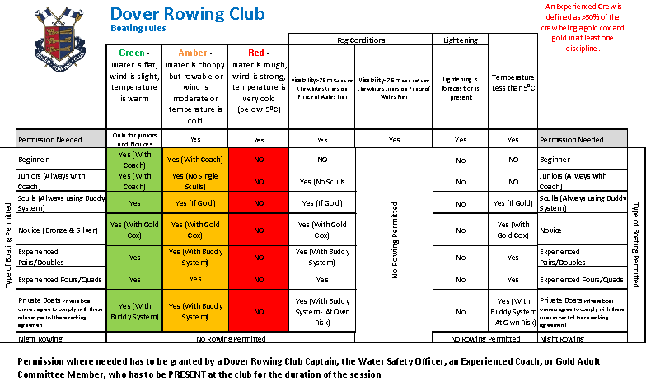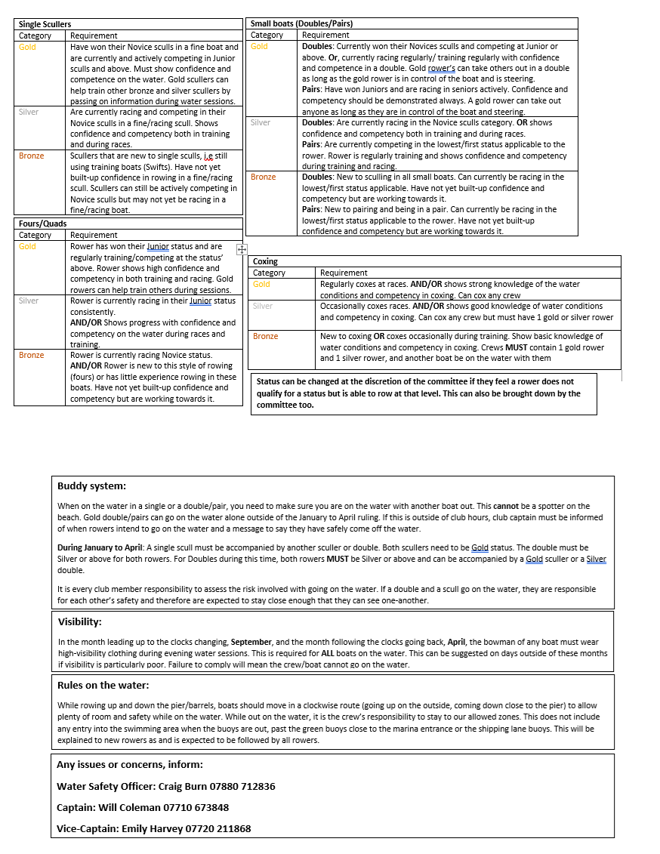

Harbour Rowing Area
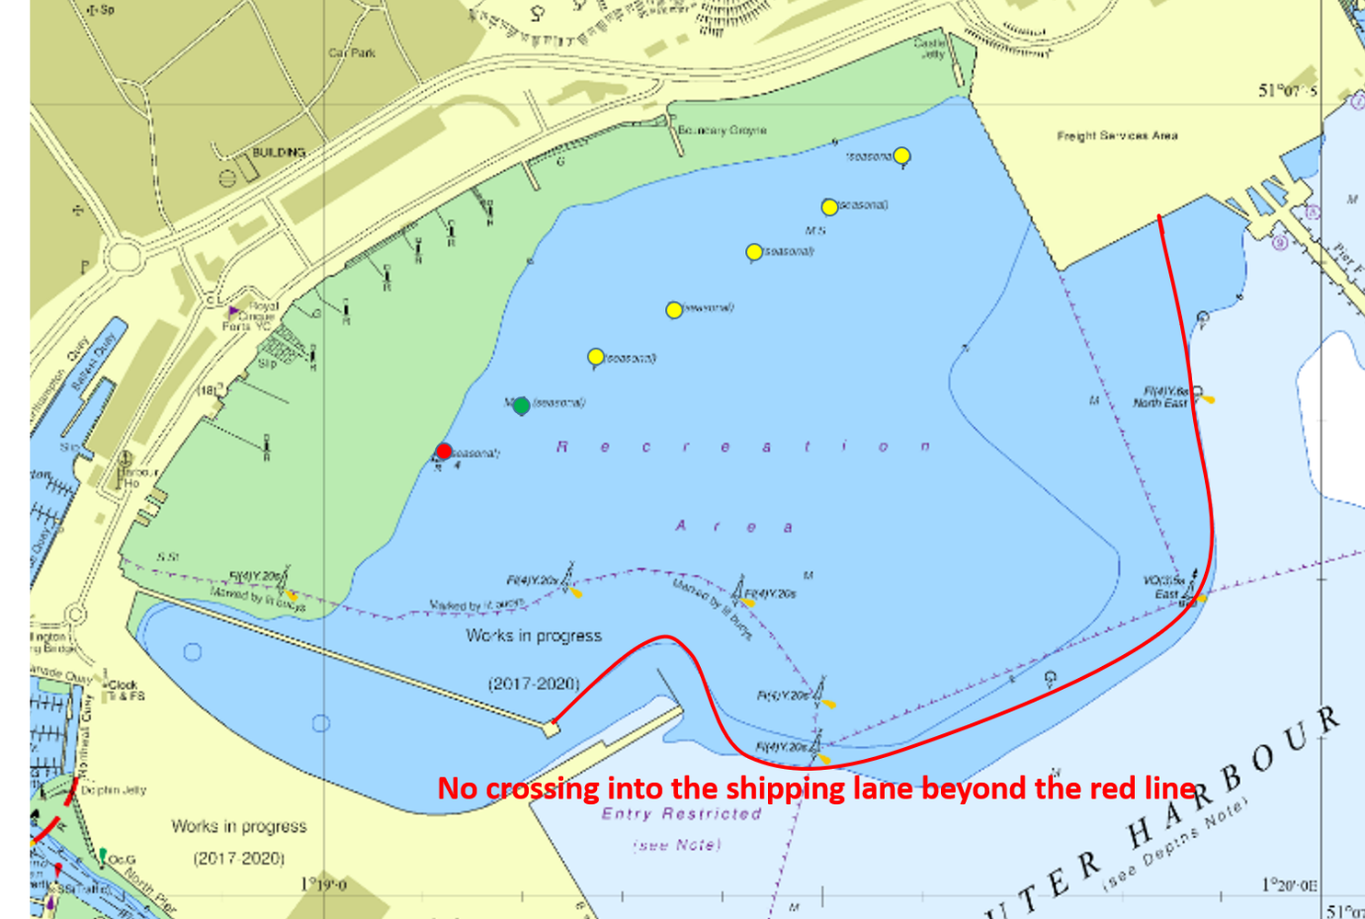

Cold Water Immersion and Hypothermia

The Captain, the Vice-Captain and the Water Safety Advisor will take account of the risks of cold water immersion when planning outings. Checks will include:

- Local weather forecasts plus local observation immediately before outings to check for weather/water/tide and classify as in the table above
- Additional cold water rules will apply during winter months as stated in yellow type in above
- Coaches, crews and coxswains will check integrity of key safety features prior to each outing.
- Coaches, crews and coxswains will agree any additional variations to navigation rules to minimise risk prior to the outing.
- Coaches, crews and coxswains will agree buddying systems to mitigate risk this will be mandatory during winter months.
- Coaches will check that crews and coxswains have adequate clothing for the conditions on the day.
- The Club will provide guidance on suitable clothing for cold weather on the club website and remind all members of the need for suitable clothing in the autumn of each year.
- The Club will organise capsize drill training for all members proposing to row in small boats and capsize drills and swim tests for all new members.
- In winter months the Club will ensure that crews or buddy groups carry throw lines with them in the boat at all times.
- The Club will maintain a stock of thermal blankets
- Crews will book out and in before and after each outing.
- Members will be trained in what to do in the event of immersion as part of the induction process.
- All capsizes and cold/hypothermia incidents will be recorded on the British Rowing on line system. They will also be reported and analysed at the next committee meeting to see if lessons can be learned and practice changed.

Dover harbour water temperatures: http://seatemperature.info/dover-water-temperature.html

January 9°C/48°F July 16°C/61°F
February 8°C/46°F August 17°C/63°F
March 7°C/45°F September 17°C/63°F
April 9°C/48°F October 16°C/61°F
May 11°C/52°F November 13°C/55°F
June 14°C/57°F December 11°C/52°F

Hypothermia Table

Water Temperature  in Degrees F (Degrees C) | Loss of Dexterity (with no protective clothing) | Exhaustion or Unconsciousness | Expected Time of Survival
32.5 (0.3) | Under 2 min. | Under 15 min. | Under 15 to 45 min.
32.5 to 40 (0.3 to 4.5) | Under 3 min. | 15 to 30 min. | 30 to 90 min.
40 to 50 (4.5 to 10) | Under 5 min. | 30 to 60 min. | 1 to 3 hrs.
50 to 60 (10 to 15.5) | 10 to 15 min. | 1 to 2 hrs. | 1 to 6 hrs.
60 to 70 (15.5 to 21) | 30 to 40 min. | 2 to 7 hrs. | 2 to 40 hrs.
70 to 80 (21 to 26.5) | 1 to 2 hrs. | 2 to 12 hrs. | 3 hrs. to indefinite
Over 80 (Over 26.5) | 2 to 12 hrs. | Indefinite | Indefinite

http://www.useakayak.org/references/hypothermia_table.html

Swimming and Capsize Drill Training

The Club will
- Ensure that all members participating in rowing and coxing are competent and confident in and under water and able to swim at least to the minimum standard, i.e.
- swimming at least 100 meters in light clothing (rowing kit)
- float in cold water for at least 1 minute (this can be done holding onto boat but without moving)
- treading water for at least two minutes
- swimming under water for at least 5 metres or be able to hold their breathe under water for the equivalent time
If they cannot complete any part of the above they will be required to wear a life jacket).
- Ensure all members know what to do in the event of a capsize or swamping of all boat types
- Ensure a higher level of support for juniors and beginners
- The Club will instruct members on safe capsize techniques for all boat types including:
- The need to stay with the boat and use it as a life raft
- Precautions to be adopted to reduce the risk
- The need to get out of the water quickly and on top of the boat to reduce heat loss.
- The effects of water temperature, water conditions and clothing
- Why boats turn over or get swamped – how to avoid this and what to do if it happens
- The means of summoning assistance and how to plan for this.

Capsize drill training will include
- Floating in the water without moving for 1 minute (cold water shock accustomisation)
- Getting on top of the boat
- Lying on top and paddling a boat
- Summoning help
- Buddy rescue
- Recovery using a throw line
- Getting back into the boat
- Developing confidence in the boat (drills)
- Attendance at capsize drills will be documented as part of each members membership profile.

The swimming ability of new members will be assessed during the swim test.

Equipment

Safety Aids

The Club will provide and adequately maintain
- a minimum of 4 Life Jackets and 4 buoyancy aids suitable for rowers.
- a minimum of 4 throw lines
- a minimum of 8 thermal blankets

The location of the safety aids will be communicated to all rowers and will be posted on the Safety Notice Board as well as on the Safety section of the Dover Rowing Club (DRC) website

Coaches and coxswains will check that throw lines and Life Jackets are in good order before each use and report any damage/failure to the water safety advisor. Damaged items will be quarantined and taken out or use until repaired and certificated.

All Life Jackets will be Lifejacket 150 and conform to EN396 and carry the CE mark of approval

If heavy winter clothes and/or the all-in-one ‘safety suits’ are worn, which require a high buoyancy rating (275N or 290N) the club will ensure a suitable life jacket is provided

The Club will ensure that all coxswains, launch and safety boat drivers and crew must wear Life Jackets on top of all other garments when in their respective boats.

Where, because of a medical condition, there is a risk of a prospective participant becoming unconscious they will not be allowed to take part in water based activities.

Safety equipment will be stored in a place where they can dry out naturally away from a heat source but ready for use in an emergency.

The Club will ensure that members are trained in the use of a throw line. N.B. Because the coastal situation of the club the value of a throw line from shore to boat is strictly limited. Use is likely to be restricted to boat to boat, or boat to person use and will only be carried in pairs, doubles and fours

Junior beginners must wear a Life Jacket until they have completed a swimming test, received training in capsize procedure and reached a satisfactory level of competence in the boat they are using.

Adult beginners should be offered the use of a Life Jacket

Steering and Navigation

The Club will:
- Provide advice and training for those who steer boats
- Ensure steering equipment is maintained as part of boat maintenance
- Display a plan of the Harbour including restricted areas, the local hazards and access points, including safe access from the sea in case of emergency, swamping or a decision to abort an outing.
- Ensure those who steer boats are familiar with the information in the local plan
- Provide information on requirements of Dover Harbour Board by publishing relevant notices.

Any person steering a boat takes on a highly responsible role and must:
- Communicate effectively with their crew
- Be aware of their position at all times, relative to circulation patterns and other water users
- Maintain a high level of attention, both visibly and aurally in order to be able to assess situations and take action to avoid accidents
- Learn and use concise commands for boat control both on and off the water and be able to use these correctly, clearly and instructively
- Understand and observe local navigation rules and audible and visual signals given by others.
- Know how to stop the boat safely in an emergency
- When visiting unfamiliar water (at race events), take particular care to learn local hazards, weather conditions and rules of navigation
- Be conversant with safety and rescue procedures in the case of an accident
- Recognise and respect the needs of other water users, especially swimmers
- Know what to do in the case of an accident or capsize and have practiced dealing with such an incident.
- In the case of a junior cox coxing an adult crew, an adult in the crew is responsible for the boat

Coxswains should wear suitable clothing for the weather conditions, which will not hinder movement or increase the risk of drowning

Lead rower must be aware of the symptoms and dangers of hypothermia and be willing to abort outings at the request of any crew member or symptoms occurring.

Those responsible for steering boats must be in good health with adequate vision of hearing. If this is not the case, they will not be allowed to steer boats.

Rowing or sculling after lighting up time is not allowed by the club or by Dover Harbour Board.

Boats and Blades

The Club will ensure that all equipment used for rowing, sculling, coaching and safety is safe and adequate for its intended purpose and that it does not expose its users to danger. The Club will also ensure that this equipment is properly and regularly maintained.

The Club will instruct participants in the process of equipment checking as part of their induction and at regular intervals to ensure that it is done prior to each outing.

In the event of being swamped all boats must have sufficient buoyancy, together with their blades or sculls to support a seated crew of the stated design weight such that the rowers torsos remain out of the water and the boat can be manoeuvred.

The Club will confirm with the manufacturer, when purchasing new boats that the boat being supplied complies with British Rowing’s requirements on buoyancy.

If after risk assessment for a planned activity, it is judged that a boat, new or old has insufficient inherent buoyancy additional buoyancy will be added.

Where the construction shape of a boat or its composition is such that the bow presents a hazard in collision, a solid rubber ball of not less than 4cm diameter will be fitted.

All boats where fitted shoes or heel traps are fitted will have effective heel restraints to prevent the heel from rising higher than the lowest fixed point of the shoe or heel trap.

Buoyancy compartments will be watertight to ensure effective operation.

Rudder lines, steering mechanisms, rudder and fin will be secure and in good working order.

Buttons on oars and sculls will be secure and properly set.

Damaged equipment will be quarantined by used of a laminated “damaged boat or equipment label,” which will not be removed until after the equipment has been repaired.

Before each outing the crew, coxswain and coach will check the following;
- Buoyancy compartments, seals, hatch covers, boat hull and ventilation bungs are secure and water tight
- If applicable, bow ball is securely fixed, fully covering the bow of the boat and with no upstanding fixing screws
- Riggers, including top nuts, swivels, gates, seats and stretchers are secure and operating freely
- Heel restraints are secure separately on each shoe/heel trap and prevent the heel from rising above the lowest fixed point of the shoe/heel trap.
- Rudder lines, steering mechanisms, rudder and fin are secure and in good working order.
- Buttons on oars and sculls are secure and properly set.

Transport and Trailers

The Club will:
- Ensure that any vehicle or trailer used by the club is maintained in a roadworthy condition
- Ensure the vehicle used for towing is appropriate for the length, load and type of trailer.
- Insure the trailer
- Confirm that all drivers have the appropriate vehicle licence and insurance for the towing vehicle, trailer type, length and load
- Confirm that all drivers are competent in towing and/or minibus driving
- Provide all drivers with British Rowing Guidance on towing and loading the trailer

As a minimum the Club will
- Ensure that drivers are aware of the correct loading pattern to ensure even loading on the trailer
- Ensure adequate protection markers and lights are available
- Ensure adequate ties in good condition are available
- Before each trip the driver will check tyre pressures, including spares, lights, projection markers and the security of the load, jockey wheel and brakes
- Ensure the trailer carries a spare wheel, tools and jack for changing a wheel.
- Drivers should normally carry a passenger to navigate and help with manoeuvring and any emergency

Participants

Beginners

The Club will:
- Ensure that all beginners take part in the Club’s induction process, which has emphasis on the safety aspects of rowing, coxing and training;
- Ensure a higher level of duty of care for beginners, juniors and, where applicable, adaptive rowers and vulnerable adults
- Support the principle that safety is everybody’s responsibility
- Ensure that health, safety and welfare of the individual is the overriding principle.
- Ensure that all members set an example for beginners to follow.

Before any activity with beginners the following information will be recorded by the Club:
- Swimming ability will be assessed as part of the induction process programme
- Information concerning medical conditions that could affect safe practice
- Personal contact details for emergency contacts
- Parental or guardian consent given for juniors to participate.

The Club’s induction process will provide basic information of the following topics:
- Risk assessments – what they are and why they need to be done
- Local hazards, what they are, how are they controlled
- Navigation rules, where not to go and reasons for rules.
- Emergencies, what to do, how to summon help
- Equipment, function and safety checks to perform before each outing
- First Aid, who are first aiders and location of first aid box
- Incident reporting – what needs reporting to whom and why
- Safety equipment – types, storage, rules on use, inspection, maintenance and location
- Club Officers: Safety Advisor, Captain, Welfare Officer, etc.,
- Capsize, swamping – what to do if it happens to you or someone else
- Life Jackets, types rules on wearing, how to use, maintenance and location
- Clothing what to wear and what not to wear and why
- Cold water immersion and hypothermia – issues, controls and reporting
- Supervision – when they can and cannot go afloat or train on land and training times, including restrictions for juniors concerning weight training
- Boat/outing logging – why necessary for emergencies
- Weather – availability of local forecasts and awareness of local conditions
- Boat outing restrictions, temperature, water conditions, tides and timing including ban on night, poor visibility rowing
- Safety notice board location and contents
- Boat types – restrictions on racing boats
- Personal responsibility for safety.

All the above will be supported by documentation of the safety section of the DRC website.

The Club will have the following in place with regard to beginner’s activities:
- Risk assessments
- Trained coaches Level 1 for land based and Level 2 or Session Coach for water activities
- Boating board – outing times, duration
- Safety Notice Board
- Capsize drill – systems for ensuring beginners know what to do, via practices and demonstrations etc.
- System for restricting access to damaged equipment
- Ensure swimming tests and capsize drills will be part of the induction process
- If a member is unable to swim they may not take part in water activities
- Have a policy for wearing Life Jackets for beginners and juniors and enforce

Juniors

- All yr. 7’s may use the ergos.
- Before they may row on the water they must satisfy the following:
- Complete a capsize drill.
- Swim at least 100 metres in light clothing (rowing kit).
- Tread water for at least two minutes.
- Swim under water for at least 5 metres or be able to hold their breathe under water with the equivalent time (If they cannot complete the swim part of the test they will be required to wear a life jacket).
- Complete a 1 km ergo in less than 5 minutes 30 seconds.
- Lift and carry (between two) on their shoulder, down the beach and back up again, a 30 kg bar.
- Be able to sit in a boat, holding their blades, without the shoulders shrugged, with their elbows bent at 90 degrees.

The Club will ensure that:
- A high level of duty of care is promoted for all juniors
- Juniors below the age of 17 do not participate in weight training except to use hand weights during circuit training
- Juniors aged 18 and above will be instructed in safe weight training technique before lifting weights and be supervised during weight training sessions.
- All the requirements for beginners above apply equally to junior members. In addition before any activity takes place the Club will record:
- swimming ability after the swimming test
- parent, carer, guardian consent to act “in loco parentis” for the administration of emergency first aid, or other medical attention if the need arises
- personal contact details and emergency contacts
- written consent by parent carer or guardian before any activity takes place
- written consent to parental agreement to the Club’s policy with regard to taking
- photographs or videos.

If a junior cannot complete the swim part of the test they will be required to wear a life jacket in all boat outings. Juniors will be consulted with regard to Club policies to ensure that they are appropriate for juniors and to gain ownership and adherence.

Indoor Rowing

Within the Club, indoor rowing is used as part of overall training for rowers. Requirements with regards to general health apply to indoor rowing.

The Club will:
- provide safe and serviceable machines
- Provide induction training for beginners
- Record all incidents regarding the use of indoor rowing machines on the British Rowing incident reporting system.
- Encourage self-recording of performance
- Assess and manage the risks prior to running an activity or event
- Maintain high standards of equipment hygiene by encouraging members to clean machines after each session
- Monitor posture and technique and correct faults as the occur

Monitoring

Incident reporting

The Club will:

- Encourage within the Club the reporting of incidents and near incidents using the British Rowing on line reporting system.
- Ensure that club members are aware of what constitutes an incident or near incident that need reporting and aware of how to report them on line
- Set up a system in the Club to ensure all incidents are reported to the Committee and the Regional Safety Advisor. The Committee will
- Review safety incidents at committee meetings on a monthly basis
- Inform members, including on the safety notice board, of incidents and near incidents and actions to be taken to avoid repetition

Safety Auditing

The Club will ensure that an accurate annual Water Safety Audit is completed and reported on time to the Regional Safety Advisor through the British Rowing on-line system.

The Committee will review the findings of the Club’s Water Safety Audit and implement its recommendations as appropriate.

The Club will act on any recommendations or non-compliances they or the Regional Water Safety Advisor identify in the Water Safety Audit.

Health

Sunburn, Heat Stroke and Exhaustion

The Club will advise members about the risk of sunburn, heat stroke and heat exhaustion as part of the induction process and again before the beginning of each regatta season. As part of this advice the Club will:
- Advise members on the need to wear clothing to protect them from the sun, hats long sleeved shirts sunglasses and the use of high factor sun block
- Advise members on the need for fluid intake, before during and after training or racing
- Consider changing training times and duration to avoid risk from exposure to the sun
- Coaches will look out for the signs of over exposure to the sun and warn members to cover up where appropriate
- Advise members to bring a ‘pop-up’ tent to regattas for protection from both sun and rain.
- Advise members of the need to avoid caffeine and alcohol if heat stroke or heat exhaustion are a risk.
- Young members and those with fair skins will be reminded to take extra care

First Aid

The club will:
- Have an emergency action plan (EAP) within the club safety policy to ensure that first aid is available during all club activities.
- Communicate the EAP to members through the club website and on the safety notice board along with emergency numbers and exact location of Club including post code
- Encourage club first aiders to maintain their certification
- Keep a record of who the first aiders are and display on Safety Notice Board
- Provide suitable quantities of First Aid materials within boxes clearly marked as ‘Fist Aid’.
- First Aid boxes will be located on the shelf above the weights and in the green and the brown boxes. When a safety / coaching launch is used, a first aid box will be situated here also.

Appendix 1: The use and care of Life Jackets

Who must/should wear?

Life Jackets must be worn by all coxswains, launch and safety boat drivers and crew over the top of all other clothing.

Buoyancy aid jackets must be worn by junior members 18 years or below who have not completed the Club’s swimming test as detailed above

Before Use - Check

- That there is no external damage to the Life Jacket
- The straps are in working order
- The CO2 cylinder has not been fired
- The manual activation cord is present.

How to wear

Life Jackets should be of the correct size to be a comfortable but not tight fit, when fastened correctly. Any straps should be adjusted so that the jacket will not slip over the head

Any crotch straps should be fastened

After wear

Note any damage or if it has been activated report to club safety advisor or senior member of the Club and quarantine with a “boat/equipment damaged” label and place on work bench.

Otherwise hang up to dry out naturally

Do Not

Abuse Life Jackets by drying with artificial heat, sticking safety pins in them or placing boats or equipment on them.

Inspection / maintenance of life jackets

Life Jackets must be inspected at least 3 monthly and a record kept of the following

- All webbing, stitching, buckles and zips are in good order.
- Where appropriate, the CO2 cylinder is free from corrosion and screwed up tightly and ensure that it has not fired.
- The inflation bladder must be checked for leaks by inflating.
- Check foam Life Jackets for deterioration of outer fabric and foam filling.

Any Life Jacket(s) not meeting inspection criteria will be quarantined and physically separated from other Life Jackets until repaired and certificated or destroyed.
Appendix 2: Capsize and Recovery and ‘Rough Sea Landing’
Three key principles:
- Get free from the boat
- Get out of the water
- Get off the water
Remember:
Stay with the boat unless doing so places you in greater danger. It is your life raft
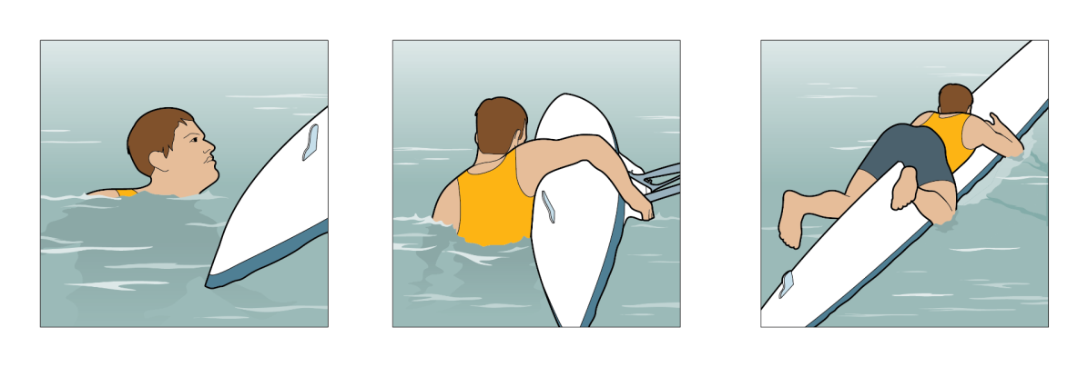
‘Buddy Rescue’
Climb onto stern of boat and side astride
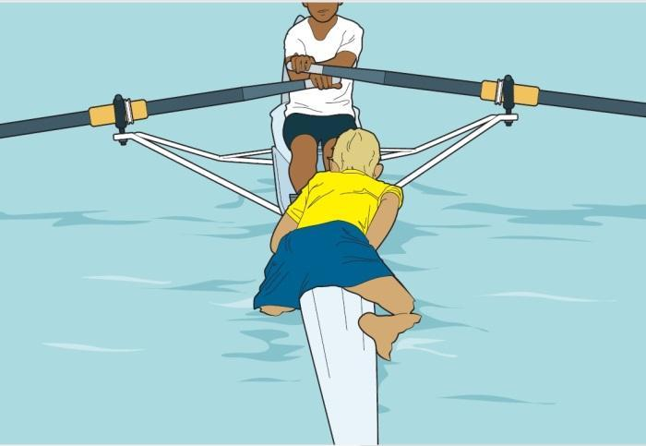
‘Rough Sea Landing’
If a boat has taken on water such that it may be damaged by or too heavy to lift it is safest to turn it in the water.
This is done by removing blades, seats and other loose items, turning the boat into the waves (away from the shore) and lifting it out of the water upside down.
It is vital that crew members on the seaward side, including the coxswain, hold onto the boat at all times whilst other crew members collect blades, seats etc., and place them on the shore.

Appendix 3: Boat Outing Safety Policy

Rules are to be adhered to at all times

All boats (exception of single sculls) will carry a throw line

No single scull, double scull or pair boat is allowed out on its own, regardless of experience, without another boat on the water using the buddy system or a watcher on the beach (with a mobile phone)

NB: from January to April inclusive, a single scull must be accompanied on the water by a double scull with experienced rowers, or by a four

Quads and fours are allowed out on the water alone provided that there is an experienced cox, coach, oarsperson, within the boat, and these experienced members are sufficiently happy that the crew is able to manage the boat OR there is sufficient strength within the boat to lift it safely into and out of the water (specifically with outings involving juniors).

No crew or person, regardless of experience, is allowed to row in the dark. It is considered dark if the light house is illuminated. Common sense must also be used. You must not place yourself or the boat in dangerous situations. If it is getting dark, get in.

No crew or person, regardless of age or experience, should go afloat if conditions are deemed too rough by either the Dover Rowing Club Water Safety Advisor, the Captain, or an experienced coach of the club, who must be PRESENT at the club for the duration of the outing. If it is rough and there are none of the above members present then no crews are to go afloat.

No junior/s (under 18) are allowed afloat without an experienced coach, Club Captain, Vice Captain or Junior Coordinator present.

Crews must not go afloat outside of club hours, which are agreed as 1700-2000hrs from Monday to Thursdays, and Sunday mornings from 1000hrs. No crews have permission to boat outside of these hours, regardless of club position or experience.

Boating outside of club hours is by permission only (as above).

All outings must be recorded on the boat outing board (Google sheet) prior to boats going afloat.

Boats are to be used in the following order:
Middle bay – non-racing boats
First bay – racing boats
Fours:
Archers Court
Snapperjack / sarah goodwin
Phil Phillips
Lily-Ellen
Julie Rose Stadium 1
Robert E. Crone Racing Crews
Bailey's Burgashell Racing Crews

Pairs/Doubles
Timber Woods
Kate Snape
Sooty & Sweep Oar
Anna Stampton
Charlie Kent Racing Crews
Lee Stampton Racing Crews
Turnpenny Racing Crews

Singles
Dimpy
Oystercatcher
Henry Pelley
Curlew
Jacky Silk
Aquaholic
Moira May
Roger cuff ll
Tony Burrows Racing Crews
Filia Dubris Racing Crews
Julie Rose Stadium 2 Racing Crews

If in doubt, please contact the following:

Water Safety Advisor Craig Burn 07880 712836
Club Captain William Coleman 07710 673848
Club Vice-Captain Emily Harvey 07720 211868

Thanks for your co-operation

Dover Rowing Club Committee 2025

Appendix 4: Emergency Action Plan

Incidents in the Club House
Medical emergencies sustained at the club are likely to be either cuts and grazes or an athlete having breathing difficulty during exercise.
In either event, a member who has received First Aid training should provide initial support to the injured person. General guidance for these events includes;

Cuts and grazes: most cuts and grazes are minor and can be treated. Cleaning them thoroughly, stopping the bleeding and covering them with a suitable plaster or dressing is generally all that is needed.
You should not give the patient any form of pain relief, as some people can have an allergic reaction to certain medicines. The patient should seek their own pain relief.

Breathing difficulty sustained during exercise: it is recommended that members do not undertake high intensity ergo sessions whilst at the club on their own. Where this is being done, members should have a mobile phone so they can call for assistance if needed.
There are many reasons why you might develop trouble breathing during exercise including having recently begun an exercise program, exercise-induced asthma or a hiatal hernia.
If shortness of breath is experienced during exercise, the athlete must stop immediately, and seek medical advice. This will mean contacting your GP as soon as possible for a thorough chest examination.

In the event of a capsize
- If out of your depth & unable to wade ashore, hold onto the capsized hull as a buoyancy aid & attempt to swim it to shore.
- If the water is cold, use the three key principles:
- Get free of the boat
- Get as much of your body out of the water as soon as possible
- Get to shore and off the water (by lying astride the boat and paddling).
- Other boats in the vicinity should fetch help.DO NOT ATTEMPT TO RESCUE FROM ANOTHER ROWING SCULL - you are likely to tip over, putting more people in the water with no one to get help.

In The Event of a Serious Incident
- IN A MEDICAL EMERGENCY, INCLUDING A CREW MEMBER BEING TAKEN SERIOUSLY ILL OR BECOMING UNRESPONSIVE, IMMEDIATELY:
- Raise the Alarm with other boats or people on the beach.
- Use a cell phone to dial for emergency assistance 999; OR if no cell phone available row to the beach and use the landline in the Sea Sports centre, or in the Hythe restaurant above the rowing club, calling 999 and indicate the closest access location (should there be building works in process on the road outside)

- Location of Dover Rowing Club (for Emergency Services)
Esplanade (same location as the Sea Sports Centre)
Dover CT17 9FS

Possible serious incidents associated with rowing
The following gives guidance for recognising and treating possible serious incidence associated with rowing.

Hypothermia
The symptoms of hypothermia depend on how cold the environment is and how long you are exposed for. Severe hypothermia needs urgent medical treatment in hospital. Shivering is a good guide to how severe the condition is. If the person can stop shivering on their own, the hypothermia is mild, but if they cannot stop shivering, it is moderate to severe.
Mild cases
In mild cases, symptoms include:
- shivering,
- feeling cold,
- low energy,
- discomfort at higher temperatures than normal, or
- cold, pale skin.
Moderate cases
The symptoms of moderate hypothermia include:
- violent, uncontrollable shivering,
- being unable to think or pay attention,
- confusion (some people don't realise they are affected),
- loss of judgment and reasoning,
- difficulty moving around or stumbling (weakness),
- feeling afraid,
- memory loss,
- fumbling hands and loss of coordination,
- drowsiness,
- slurred speech,
- listlessness and indifference, or
- slow, shallow breathing and a weak pulse.
Severe cases
The symptoms of severe hypothermia include:
- loss of control of hands, feet, and limbs,
- uncontrollable shivering that suddenly stops,
- unconsciousness,
- shallow or no breathing,
- weak, irregular or no pulse,
- stiff muscles, and
- dilated pupils.
Although hypothermia is defined as occurring when the body temperature drops below 35°C (95°F), mild hypothermia can start at higher body temperatures.
As the body temperature decreases further, shivering will stop completely. The heart rate will slow and a person will gradually lose consciousness. When unconscious, a person will not appear to have a pulse or be breathing. Emergency assistance should be sought immediately and CPR provided while the person is warmed. (see CPR resuscitation procedure below)

Treating hypothermia
As hypothermia can be a life-threatening condition, seek medical attention as soon as possible.
Hypothermia is treated by preventing further heat being lost and by gently warming the patient.
If you are treating someone with mild hypothermia, or waiting for medical treatment to arrive, follow the advice below to prevent further loss of heat.
Things to do for hypothermia:
- Move the person indoors, or somewhere warm, as soon as possible.
- Once sheltered, gently remove any wet clothing and dry the person
- Wrap them in blankets, towels, coats (whatever you have), protecting the head and torso first
- Your own body heat can help someone with hypothermia. Hug them gently
- Increase activity if possible, but not to the point where sweating occurs, as that cools the skin down again
- If possible, give the person warm drinks (but not alcohol) or high energy foods, such as chocolate, to help warm them up
- Once body temperature has increased, keep the person warm and dry
It is important to handle anyone that has hypothermia very gently and carefully.
Things you should NOT do:
- Don't warm up an elderly person using a bath, as this may send cold blood from the body's surfaces to the heart or brain too suddenly, causing a stroke or heart attack;
- Don't apply direct heat (hot water or a heating pad, for example) to the arms and legs, as this forces cold blood back to the major organs, making the condition worse
- Don't give the person alcohol to drink, as this will decrease the body's ability to retain heat
- Don't rub or massage the person’s skin, as this can cause the blood vessels to widen and decrease the body’s ability to retain heat. In severe cases of hypothermia there is also a risk of heart attack

Near-Drowning
The goal is to safely rescue the victim and begin first aid.
In a near-drowning emergency, the sooner the rescue and first aid begin, the greater the victim's chance of survival. Do not endanger yourself in rescuing the victim during this process.
Rescue options to reach the drowning victim in the water:
- Use a Throw Line
- Throw a rope with a buoyant object
- Bring a boat alongside the victim and tow the victim to shore. Do not haul the victim into the boat because it may cause the boat to capsize, and both of you will be in the water. Cold water may render the victim too hypothermic to grasp objects within their reach or to hold while being pulled to safety
- As a last resort, you can attempt a swimming rescue if you are sufficiently trained in water rescue. Do not attempt a rescue beyond your capabilities. Otherwise, you may harm yourself
- For a swimming rescue, approach the person from behind while trying to calm the victim as you move closer. A panicked victim can pull you down
- Grab a piece of clothing or cup a hand or arm under the victim's chin and pull the person face up to shore while providing special care to ensure a straight head-neck-back alignment especially if you think the person has spine injuries

First aid for a near-drowning victim
The focus of the first aid for a near-drowning victim in the water is to get oxygen into the lungs without aggravating any suspected neck injury.
If the victim's breathing has stopped, give 5 mouth-to-mouth rescue breaths as soon as you safely can. This could mean starting the breathing process in the water.
Once on shore, reassess the victim's breathing and circulation (heartbeat and pulse). If there is breathing and circulation without suspected spine injury, place the person in recovery position (lying on the stomach, arms extended at the shoulder level and bent, head on the side with the leg on the same side drawn up at a right angle to the torso) to keep the airway clear and to allow the swallowed water to drain. If there is no breathing, begin CPR. Continue CPR until help arrives or the person revives.
Keep the person warm by removing wet clothing and covering with warm blankets to prevent hypothermia.
Remain with the recovering person until emergency medical personnel have arrived.
STRONG RECOMMENDATIONS:
- Do not go out rowing alone, ever, when the water temperature is below 10 degrees C. Hypothermia is deadly quick at lower temperatures.
- Always row with at least one other boat, or with the coach/safety boat.
- Always have your mobile phone with you if there is no coach boat, so that you can call 999 for help. Keep it in a zip-loc bag - then it won't sink!

All crews are advised to ensure they carry a mobile phone when on the water.
In an emergency call 999.

Hands-only CPR
To carry out a chest compression:
Place the heel of your hand on the breastbone at the centre of the person’s chest. Place your other hand on top of your first hand and interlock your fingers.
Position yourself with your shoulders above your hands.
Using your body weight (not just your arms), press straight down by 5-6cm (2-2.5 inches) on their chest.
Keeping your hands on their chest, release the compression and allow the chest to return to its original position.
Repeat these compressions at a rate of 100 to 120 times per minute until an ambulance arrives or you become exhausted. (The rate is equal to the beat of ‘Staying Alive’ by the Bee Gees)
When you call for an ambulance, telephone systems now exist that can give basic life-saving instructions, including advice about CPR. These are now common and are easily accessible with mobile phones.

CPR with rescue breaths
If you’ve been trained in CPR, including rescue breaths, and feel confident using your skills, you should give chest compressions with rescue breaths.
30 compressions to 2 rescue breaths
If you're not completely confident, attempt hands-only CPR instead

Useful Contact details:
Minor injuries unit
Buckland Hospital
Coombe Valley Road
Dover, Kent
CT17 0HD
Tel: 01304 222621

Dover Harbour Board Port Control: 01304 206063
Dover Harbour Board Police: 01304 216084
Captain: William Coleman 07710 673848
Vice-Captain: Emily Harvey 07720 211868
Vice-Captain: Ella Cook
Water Safety Advisor: Craig Burn 07880 712836
Welfare Officer: Damion Napier 07999 311928

Address: Dover Rowing Club, Esplanade, Dover CT17 9FS

