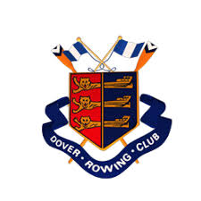
Boat Outing Safety Policy

Rules are to be adhered to at all times

All boats (exception of single sculls) will carry a throw line

No single scull, double scull or pair boat is allowed out on its own, regardless of experience, without another boat on the water using the buddy system or a watcher on the beach (with a mobile phone)

NB: from January to April inclusive, a single scull must be accompanied on the water by a double scull with experienced rowers, or by a four

Quads and fours are allowed out on the water alone provided that there is an experienced cox, coach, oarsperson, within the boat, and these experienced members are sufficiently happy that the crew is able to manage the boat OR there is sufficient strength within the boat to lift it safely into and out of the water (specifically with outings involving juniors).

No crew or person, regardless of experience, is allowed to row in the dark. It is considered dark if the light house is illuminated. Common sense must also be used. You must not place yourself or the boat in dangerous situations. If it is getting dark, get in.

No crew or person, regardless of age or experience, should go afloat if conditions are deemed too rough by either the Dover Rowing Club Water Safety Advisor, the Captain, or an experienced coach of the club, who must be PRESENT at the club for the duration of the outing. If it is rough and there are none of the above members present then no crews are to go afloat.

No junior/s (under 18) are allowed afloat without an experienced coach, Club Captain, Vice Captain or Junior Coordinator present.

Crews must not go afloat outside of club hours, which are agreed as 1700-2000hrs from Monday to Thursdays, and Sunday mornings from 1000hrs. No crews have permission to boat outside of these hours, regardless of club position or experience.

Boating outside of club hours is by permission only (as above).

All outings must be recorded on the boat outing board (Google sheet) prior to boats going afloat.

DRC Captain – Will Coleman – 07710 673 848
DRC Vice Captain – Emily Harvey – 07720 211868
DRC Safety Advisor – Craig Burn – 07880 712836

