

**Regatta Safety & Emergency Plan 2025**

Eastbourne Regatta will take place on Saturday 10th May 2025 starting from Fisherman’s Green, Royal Parade, Eastbourne, BN22 7LD.

The regatta is weather dependent and a decision will be made at 06:00 on the morning of the regatta.

There will be 12 lanes for racing and the event is planned to start at 09:30

**Parking**

Unloading & loading will be undertaken along the access road indicated on the map below. Vehicles once unloaded will need to be moved to the cordoned off section of the adjacent car park. Permits will be required as pay & display rules will be enforced. Please collect a parking permit from the ERC member on duty or clubhouse on the day.

Trailer Entrance Trailer Exit Trailer Unloading/Loading Trailer Parking

Please avoid setting up on the beach directly in front of the Inshore Lifeboat as they may be called out at any time.

Please take extra care when moving equipment from the trailers to the beach, these are working fishing/boating beaches and therefore all manner of hazards may be present on the beaches and surrounding areas. Most common hazards will be cables/ropes, lobster pots, winches, metal poles, plastic tubes, boats. Other hazards that are present are the rock/sea defences located on the 2 beaches to the west of the clubhouse.

The race course is detailed below:

Turn Buoys First Aid Tent Regatta Control/Start Line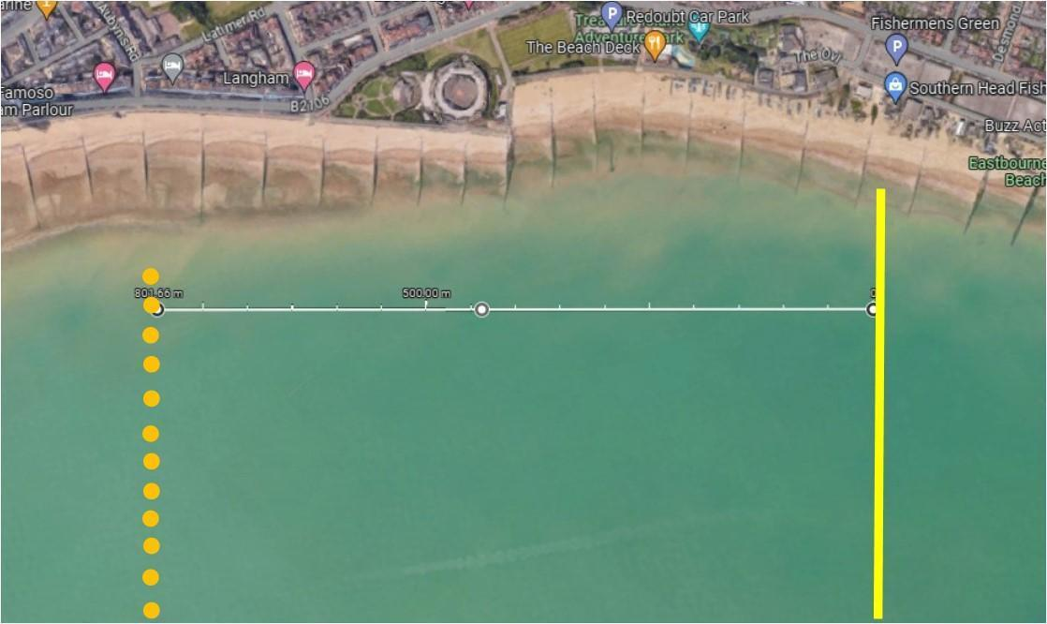

**General Safety Provisions**

All crews are expected to adhere to the CARA Rules of Racing and all participating Club Captains shall attend a Safety Briefing prior to the start of racing.

There may be times when crews need to navigate with other water users as well as the fixed buoys,

The Event Organisers shall:

* Ensure there is First Aid cover, provided by: Member of ERC
* Ensure that clubs are provided with parking and unloading information, including a map
* Provide sufficient and proficient marshals to assist on the day
* Ensure that clubs are notified in advance of safety instructions regarding unloading /loading boats and transferring to the beach
* Communicate with club captains to ensure that no inexperience coxswains are to be used in rough conditions or with inexperienced crews and no inexperienced scullers / doubles/pairs rowers are to row in rough conditions
* Conduct a site inspection prior to the event and check for hazards such as tripping hazards from wires.
* Ensure that the Regatta Control tent is correctly erected and checked periodically

**Safety Boats**

There will be two safety boats present with two occupants in each, who have been provided with a copy of the event safety & emergency action plan in advance, and properly briefed and understand

* The load capacity of their boat
* How to provide assistance to rowing boats
* How to minimize wash
* The necessity of staying with each race and noting when races contain inexperienced /novice rowers
* How to summon assistance, including medical attention
* Where to take casualties

In addition:

* The safety boat driver is preferred to be RYA qualified to level 2, if not, then the driver needs to have proven experience / competence
* Racing is to be halted if safety cover is interrupted
* It is recommended that each safety boat should carry 4 life jackets for crew members requiring rescue.
* No rowing boats shall launch until the safety boats are on the water.

**Boat and Life Jacket Safety**

Clubs shall ensure:

* Correct rigging of the boats
* Heel restraints are strong, secure and durable and the correct length. They must be properly adjusted (each heel should be restrained to prevent it rising above the lowest fixed part of the shoe) and in working order.
* Bow balls should be in good condition and securely fixed
* Fixing screws or bolts should not represent a hazard in the event of an accident. Any sharp protrusions should be covered or removed.
* Buoyancy compartments, seals, hatch covers, boat hull and ventilation bungs must be secure and watertight.
* Life jackets will be checked to ensure
  + Appropriate size for coxes weight
  + Inflators are present and not corroded
  + There are no holes or degeneration of the material on the folds
* Failures will not go on water and will be reported via incident reports (BR website) with expectation that clubs will update when rectified

**Communication**

Regatta Control will be situated on the beach at the start/finish line. Regatta Control will have radio contact with the umpires’ and safety boats.

**Emergency Action Procedures**

**Medical support**

First Aid will be situated: In tent near to regatta control (see map above)

**Lightning / Severe weather events**

The local weather forecast will be monitored. If there is unexpected lightning / severe weather prior to the outing race crews will be told NOT to go afloat. If there is unexpected lightning / severe weather during the race, or when crews are already afloat, then crews will be told to come ashore and must do so immediately. Follow the 30/30 rule. If the time between seeing the flash of lightning and hearing the thunder is less than 30 seconds, take shelter. You are in a strike area. Remain in shelter for 30 minutes after the last flash of lightning.

**Actions by crews of Safety Boats**

If heading for casualties do so with reasonable haste but consider wash and the possibility of swamping other craft upon approach. Approach slowly, use paddles or throw line for the final approach and watch for people in water. When rescuing those in the water use basic triage, supporting most in need and unable to help themselves before those who are faring better

**Hazardous situations**

**Capsizing**

Capsizing is most likely in the single sculls, pairs and double sculls, unless the capsize has been caused by equipment failure or some other incident (like a collision or medical situation). Rower(s) are expected to right their boats and continue racing. The crews’ eligibility in the race may be compromised if they receive outside assistance.

Actions shall be:

* On capsizing a crew should do a buddy check and then proceed to right the boat and get rowing as quickly as possible. In most cases this is the most preferable option.
* If a safety boat comes to a crew’s assistance and they do not want help, it is important the crew makes it clear that they are OK and do NOT want assistance.
* The safety boat shall assess the situation and take action (unless requested not to by the crew). It shall:-
  + Establish that all persons are accounted for.
  + Standby until the crew is safely back in the boat and continuing to race or returning safely to the beach.
* If the crew needs, or requests, assistance, then:-
  + It is likely that crews from a single, pair or double will board the safety craft, and single sculls will be placed across the RIB inflation tubes. A double/pair will be lashed to the side of the rib
  + In the fours / quads if only one or two rowers need to be rescued, it may be safest to allow the remaining crew to row the boat back to shore.
  + If the whole crew from a four/quad requires rescue, it can be towed (do consider placing a person into the boat to assist in the direction stability and to steer) however the blades should be removed prior to towing.

**Swamping**

This may be of a rowing boat, a safety launch or an umpires’ launch. The vessel may be taking on water due to rough water or to a collision or some structural failure.

Actions should be:

* Those in the swamped boat should stay with the boat and row, if possible.
* Wait for assistance from safety boat
* The crew involved should raise the alarm by waving to the nearest boat and/or calling for umpire and safety boats by radio
* Safety or another craft will:-
  + Retrieve that casualties from the boat or water
  + Establish that all persons are accounted for
  + Make safe or otherwise retrieve the craft (as above)

**Person Overboard**

A person may fall from any craft into the water. It is likely to be one individual but it is possible that when assisting the recovery of a person overboard or when putting out / retrieving the weighted turns, another individual falls in.

Actions should be:

* Raise the alarm on the safety radio
* Retrieve the casualty from the water
* Establish that all casualties are accounted for
* Take casualty to shore

**Fire on-board safety or umpires’ launch**

Any craft with an engine is capable of catching fire.

Actions should be:

* Raise the alarm on the safety /umpires’ radio
* Extinguish the fire using the fire extinguisher on board
* If possible, make way to the shore
* If necessary, make preparations to abandon the craft
* Other craft should lend assistance and possibly retrieve casualties from water as necessary
* CARA officials of the day, shall reassess risk to event as whole due to loss of craft and take appropriate action

**Mechanical malfunction on safety or umpires’ launch**

Any craft with an engine is capable of becoming disabled.

Actions should be:

* Raise the alarm on the event safety/umpires’ radio
* Assign a suitable craft (with sufficient power and rope for towing) to assist the disabled craft
* Tow disabled craft to shore
* If resources permit, have second craft on standby to lend further assistance
* CARA officials of the day, shall reassess the risk to event as whole due to loss of craft and take appropriate action

**Emergency Response**

Key Steps in the event of an emergency or life-threatening injury

1. Render assistance

2. Make contact with Regatta control tent

3. Call for Help & Emergency Medical Attention:

* 999 (112)

4. Monitor and administer first aid (Defibrillator location – On wall in front of Voluntary Lifeguard attached to Eastbourne Rowing Clubhouse)

5. Send someone to meet/direct Emergency Services

6. Transfer injured to care of Emergency Team

7. Inform key people (Regatta control)

8. Complete an incident report

Be prepared to tell 999:

* Who you are, your name and call back number
* Current location of injured person
* Description of boats (if requesting on-water help)
* Where you plan to bring injured person ashore
* Age/gender/number of injured people
* Type of injury/situation

**Key Contact Details:**

Regatta address for emergency services:

Eastbourne Rowing Club, Fisherman’s Green, Royal Parade, BN22 7LD

What3Words: **emulating.salaried.linked**

**A&E**

Eastbourne District General Hospital

Kings Drive, Eastbourne

East Sussex, BN21 2UD

Tel: (01323) 417400

**Eastbourne Rowing Club Contacts**

Captain: Jon Osborn 07799702636

Secretary: Tabitha McConnell 07902949174

Welfare Officer: Phil Grove 07518793150

Water Safety Officer: Jon Reeve-Fowkes 07711777691

Chairman: Gary Hammond 07539472481

**Tide times**

Tide and sunrise/sunset times for 10th May 2025

Low Tide: 05:00 / 1.3m

High Tide: 10:56 / 6.3m

Low Tide: 17:17 / 1.2m

**Appendix 1 – Mixed Quad Race**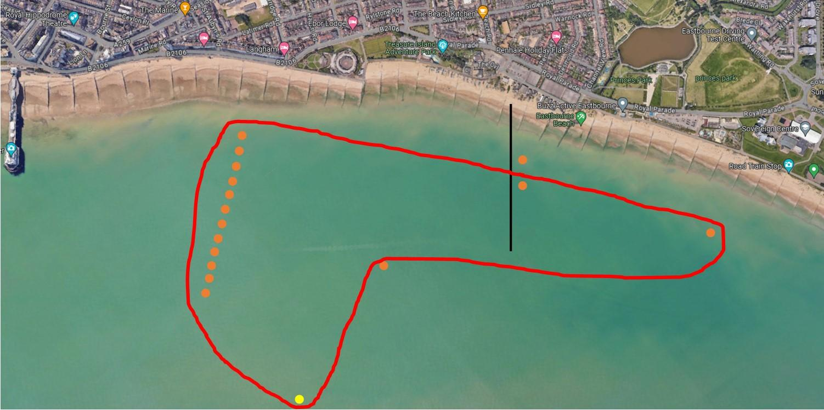

This is a fun event that will emulate an offshore style event. It will start with all crews behind the start line. There will be 3 minute, 2 minute, 1 minute then 10 second count down. If any crew crosses the line before the flag drop a 2 minute time penalty will be issued. The crews will row off along the shore heading to the first buoy turn. Coxes will then steer 90° to bow side & head up to buoy turn 12. Then head out towards a metal yellow marker buoy. Head towards the shore then along to the final buoy turn then race back & cross the start/finish line.

This race will be subject to weather conditions & tide on the day. If conditions are not favourable it will be run as a standard water start/buoy turn race.

**Appendix 2 – Regatta Risk Assessment**

