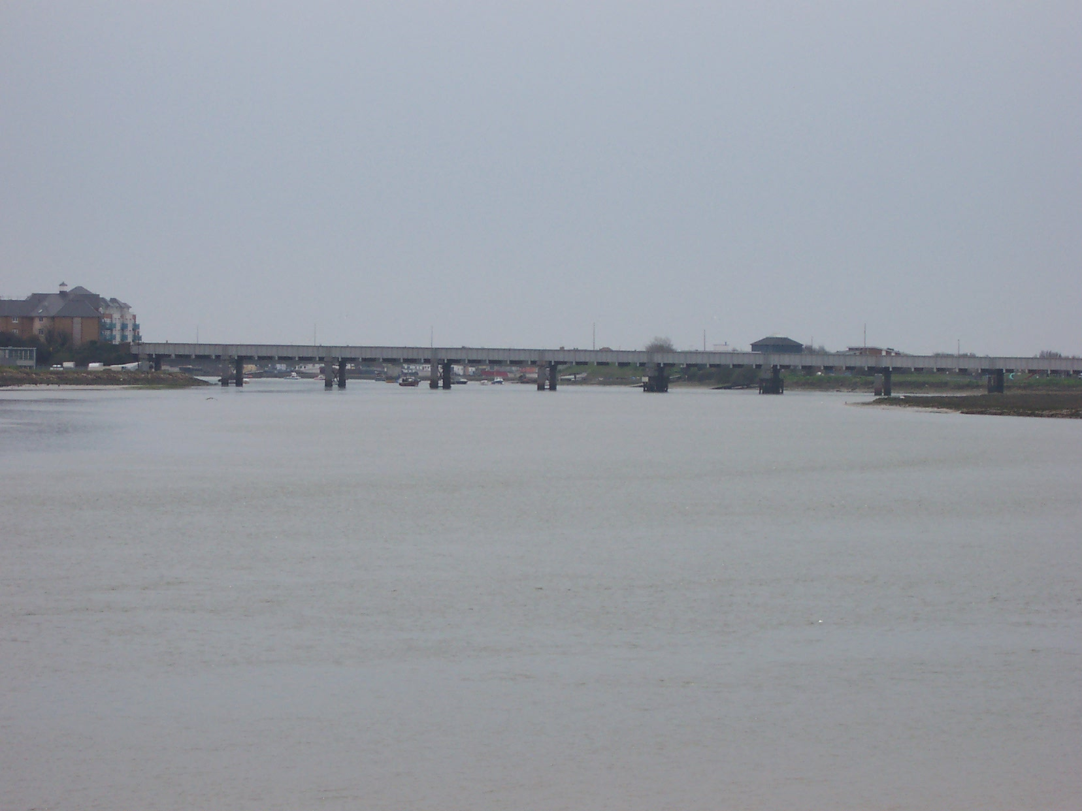 | From the start take a course for the inside of the railway bridge. This will put you in a good position for the Norfolk Road Bridge.  We will have a launch at the start.
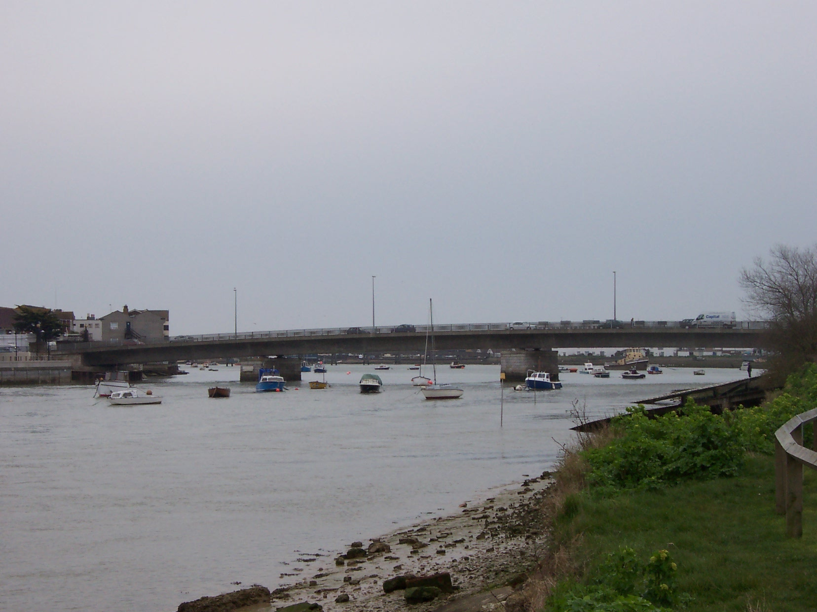 | Keep to the main channel between the railway and Norfolk Bridge.  Keep a lookout for moored boats.  You must row through the centre of the Norfolk Bridge. This will give you the best line as you head towards the Foot Bridge.
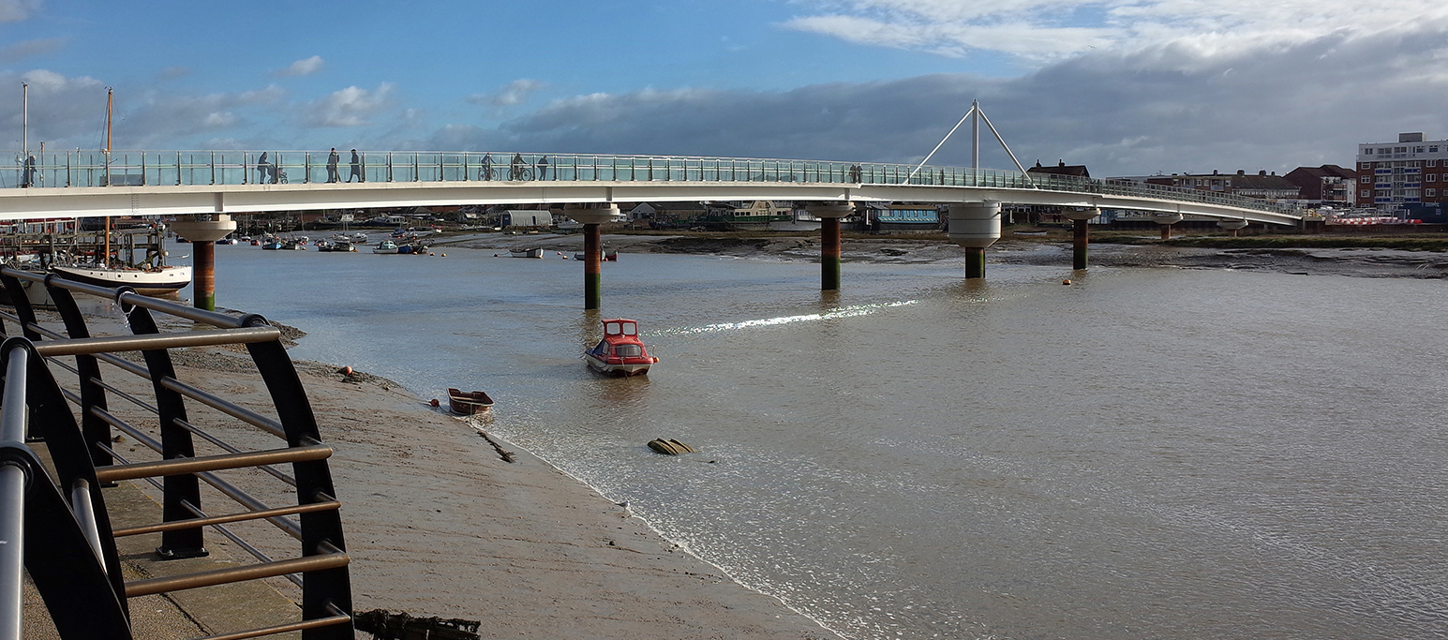  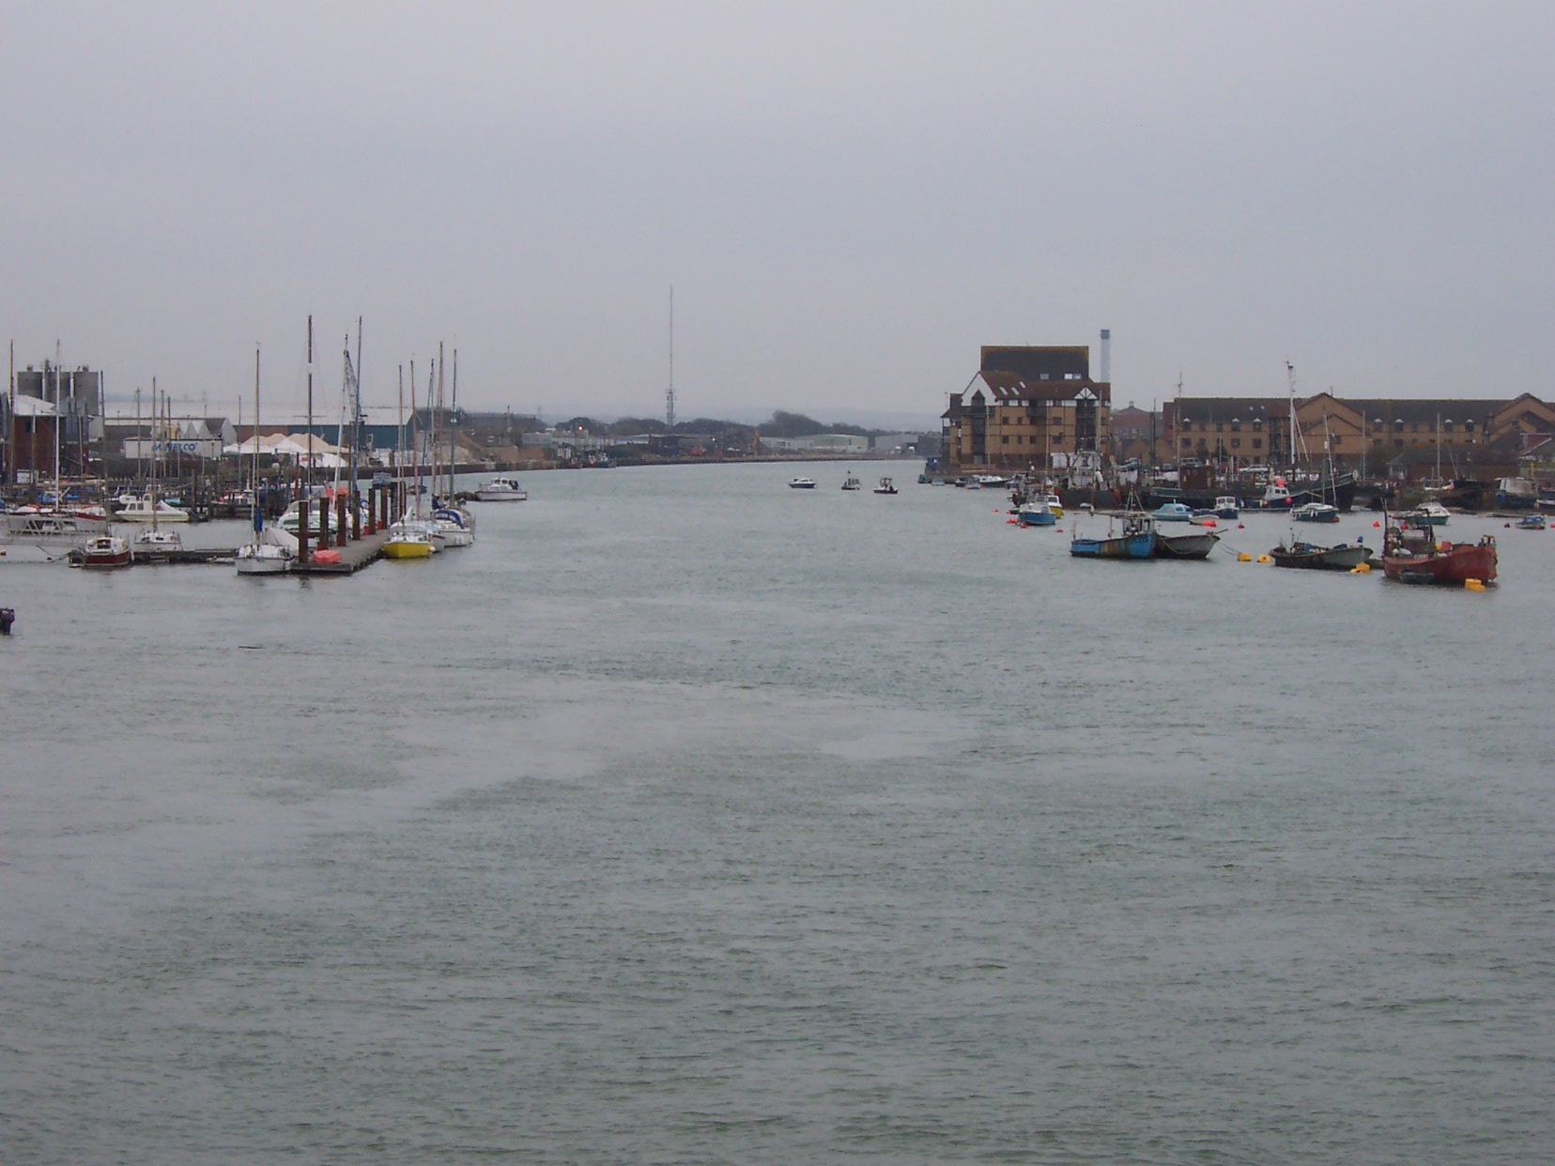 | Move out into the river to give you a line through either of the two centre arches of the footbridge.  Do not take the inside arch as pictured due to moorings on the other side. Boats may be disqualified if this occurs  The Inshore Lifeboat will be located on the inside of the bend.
From the footbridge keep to the main channel as you head down the river.

You have approximately one mile to go from here.
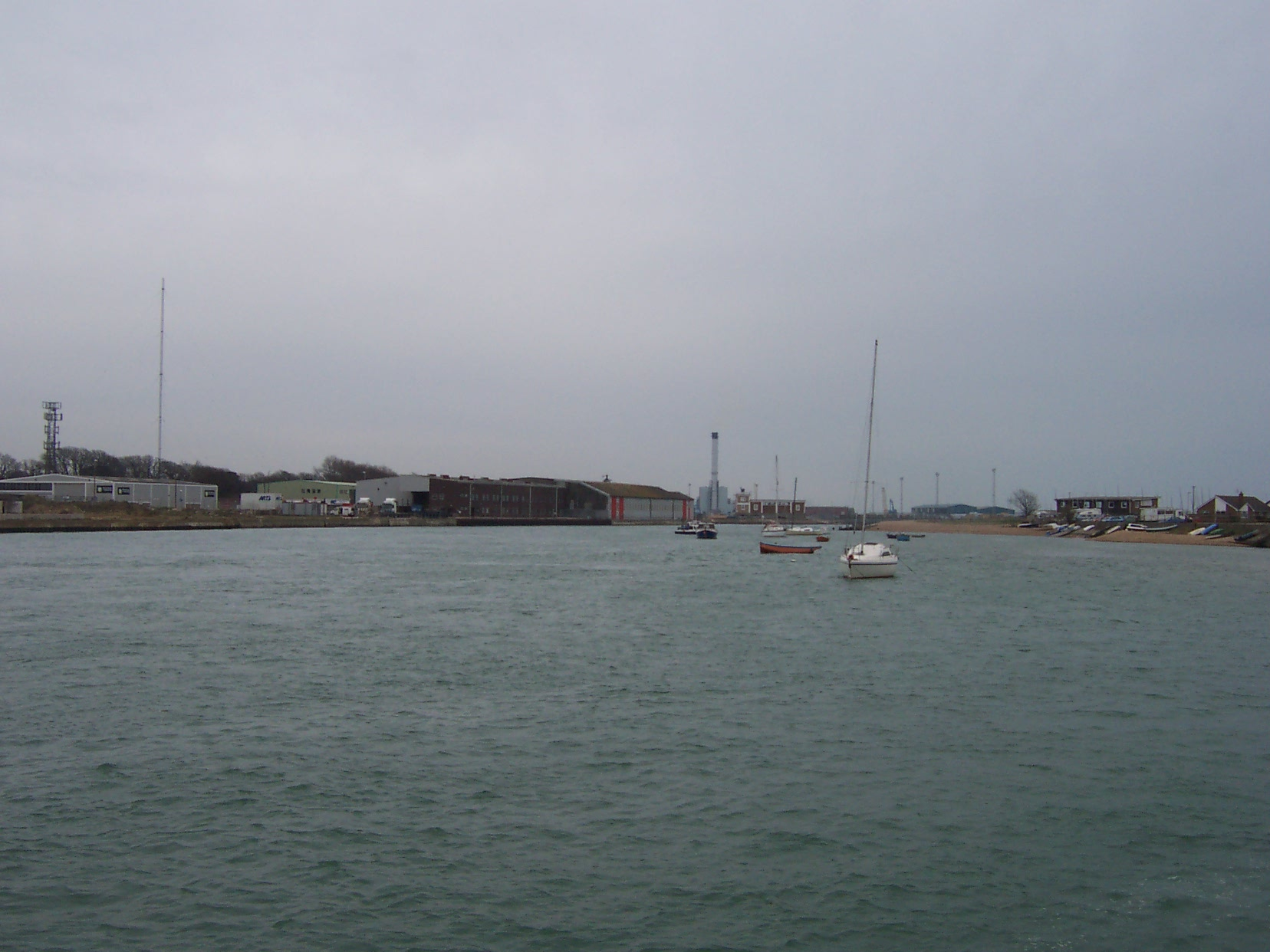 | Nearly there!  Stay on the river, do not cut inside moored boats. We can see you and you will be disqualified!  We will have a boat at the finish.

