Bexhill Regatta will take place on Sunday 23rd June 2024 in Bexhill Sea Front, outside the Boat House.

The regatta is weather dependent and will be decided upon at or before 6pm on the 22nd June

There will be 12 lanes for racing and the event is planned to start at 10:00am.

**Parking**

Parking for the regatta trailers, towing vehicles, umpires, vehicles with boats on roof racks is located with De La Warr Car Park, TN40 1DP

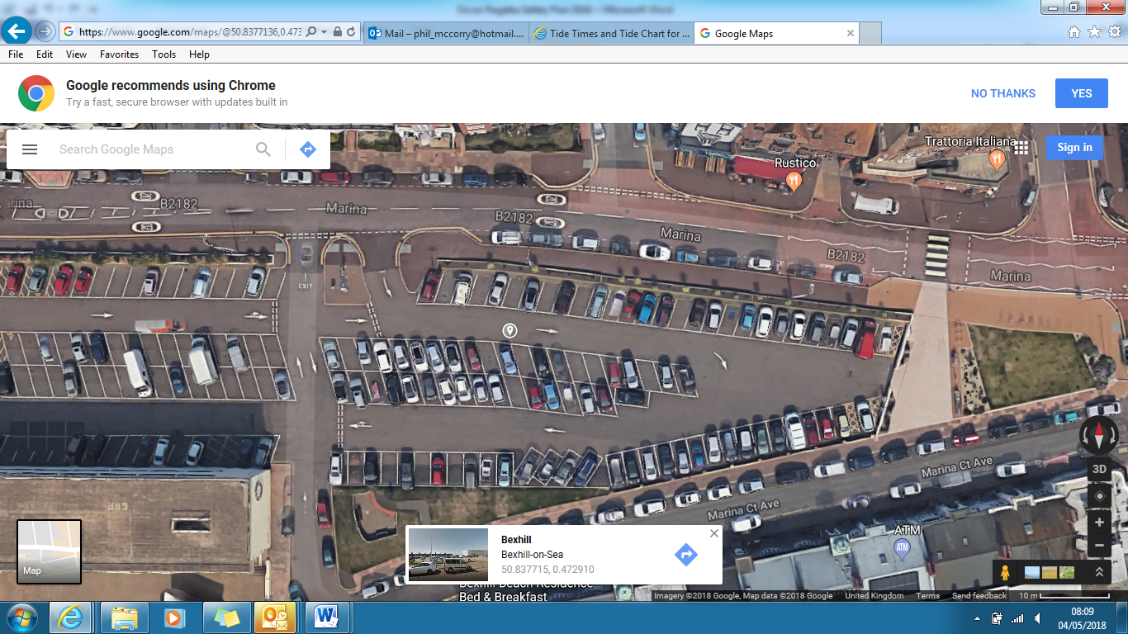

* Trailers should park in the Green area. There will be plenty of space. You can leave your towing vehicle attached or de-detach it and park it next to your trailer or anywhere in red area. Please park to the left of the green area (as you look at this image above) and point your trailer north so that it is easy to get out after. Unfortunately if you leave gaps between the trailers which are full spaces, members of the public will park there, so perhaps overlap spaces or other rower’s park there.
* We have paid for the whole red area so people can park there for free, but it is reserved for trailers, towing vehicles, umpires, cars with roof racks initially.
* Anywhere that is not in the red area is pay and display.
* A member of BRC should be on the entrance to let people in.
* Please take care when parking and unloading equipment. Anyone transferring boats to the seafront down the steps and for pedestrians and members of the public.

**PLEASE TAKE NOTICE**

Bexhill tides are quite high and we have lost a lot of beach over the years. High tide is around noon, therefore throughout the day clubs will be moving boats back up the beach. However the water may be very high and you may stuggle to rack all boats vertilcally (north to south), you may have to put them all horizontally (east to west).

There is not a lot we can do about this, other than ask clubs to spread out on the beaches to ensure there is not a mass panic for lack of space when the tide comes in.

Also when it is high water, there will be a relatively steep drop off for lauching and coming in, so please be aware of this if conditions are rough.

The image below also, shows location of First Aid Point, Start and the high beach line.

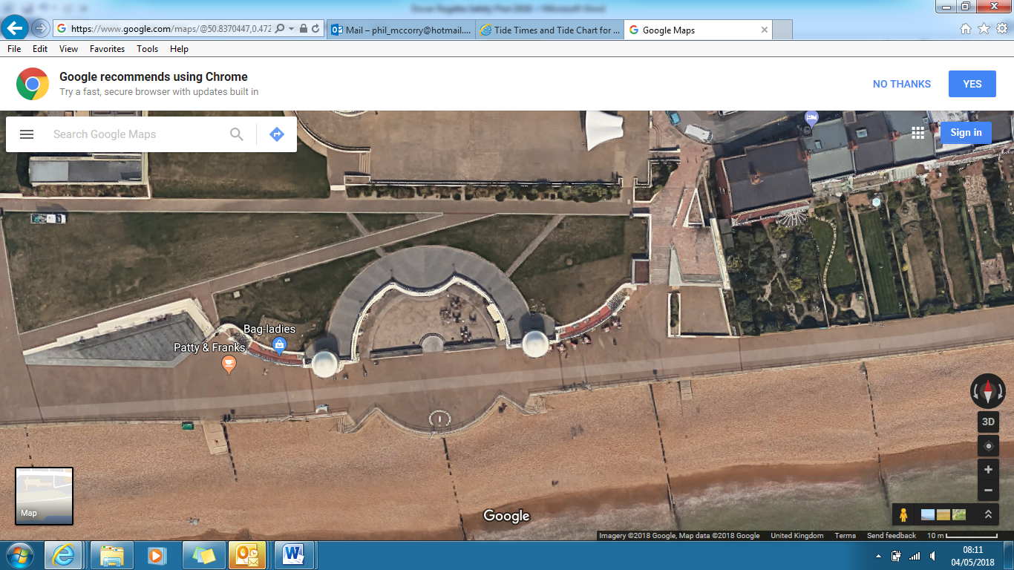

Bexhill Rowing Club

High Tide Marks Umpires Tent Start Line First Aid Tent – Hastings Life Guards  
(red lines)

The race course is detailed below –

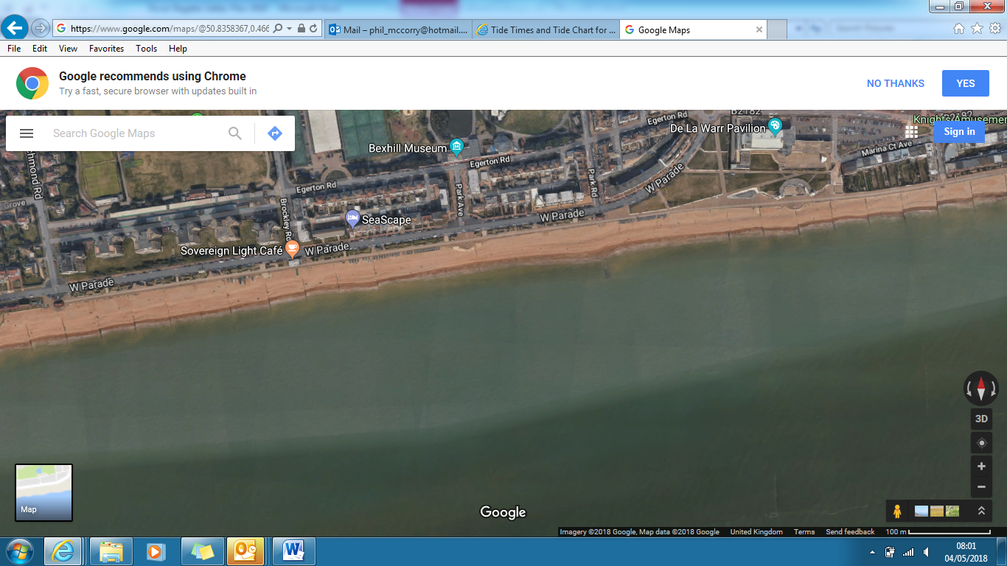

**Key**

These are the turns. There should be 11-12 out there in a straight line on the regatta day

These are not part of the racing course; they are yellow obstacles to be avoided

These are the tall sewage pipe markers. You can row inside them at your own risk at high tide.

Direction of the course towards the turns

Start Line.

1. **General Safety provisions**

All crews are expected to adhere to the CARA Rules of Racing and all participating Club Captains shall attend a Safety Briefing prior to the start of racing. This includes any restrictions (COVID-19 or otherwise) and safety precautions in place. This plan will be updated nearer the time with specific details regarding any additional measure in place.

There may be times when crews need to navigate with other water users as well as the fixed buoys,

The Event Organisers shall:

* Ensure there is First Aid cover, provided by: **Hastings Voluntary Life Guards**
* Ensure that clubs are provided with parking and unloading information, including a map
* Provide sufficient and proficient marshals to assist on the day
* Ensure that clubs are notified in advance of safety instructions regarding unloading /loading boats and transferring to the beach (wet pedestrian area between seafront and beach which is slippery when wet)
* Communicate with club captains to ensure that no inexperienced coxswains are to be used in rough conditions or with inexperienced crews and no inexperienced scullers / doubles/pairs rowers are to row in rough conditions
* Conduct a site inspection prior to the event and check for hazards such as tripping hazards from wires.
* Ensure that the Regatta Control tent is correctly erected and checked periodically

1. **Safety Boat(s)**

There will be one safety boat present with two occupants on board, who have been provided with a copy of the event safety & emergency action plan in advance and properly briefed and understand

* The load capacity of their boat
* How to provide assistance to rowing boats
* How to minimize wash
* The necessity of staying with each race and noting when races contain inexperienced /novice rowers
* How to summon assistance, including medical attention
* Where to take casualties

In addition:

* The safety boat driver is preferred to be RYA qualified to level 2, if not, then the driver needs to have proven experience / competence
* Racing is to be halted if safety cover is interrupted

No rowing boats shall launch until the safety boats are on the water.

The Umpires boat shall act as second safety boat if needed in an emergency

1. **Boat and Life Jacket Safety**

Clubs shall ensure:

* Correct rigging of the boats
* Heel restraints are strong, secure and durable and the correct length. They must be properly adjusted (each heel shall be restrained to prevent it from rising higher than 7cm measured at right angles, from the footplate) and in working order.
* Bow balls should be in good condition and securely fixed
* Fixing screws or bolts should not represent a hazard in the event of an accident. Any sharp protrusions should be covered or removed.
* Buoyancy compartments, seals, hatch covers, boat hull and ventilation bungs must be secure and watertight.
* Life jackets will be checked to ensure
  + Appropriate size for coxes weight
  + Inflators are present and not corroded
  + There are no holes or degeneration of the material on the folds
* Failures will not go on water and will be reported via incident reports (BR website) with expectation that clubs will update when rectified

1. **Communication**

Regatta Control will be situated on the beach at the start/finish line. Regatta Control will have radio contact with the umpires’ and safety boats.

**Emergency Action Procedures**

**Medical support**

First Aid will be situated: Next to the umpire’s tent as shown on the map above. This will be provided by Hastings Voluntary life guards and shall be in place from 10.00am through to the last race of the day. All medical emergencies are to be reported to the first aid point immediately. **For life and death please dial 999 and report to First Aid Point.**

**Lightning / Severe weather events**

The local weather forecast will be monitored. If there is unexpected lightning / severe weather prior to the outing race crews will be told NOT to go afloat. If there is unexpected lightning / severe weather during the race, or when crews are already afloat, then crews will be told to come ashore and must do so immediately.

Follow the 30/30 rule. If the time between seeing the flash of lightning and hearing the thunder is less than 30 seconds, take shelter. You are in a strike area.

Remain in shelter for 30 minutes after the last flash of lightning.

**Actions by crews of Safety Boats**

If heading for casualties do so with reasonable haste but consider wash and the possibility of swamping other craft upon approach

Approach slowly, use paddles or throw line for the final approach and watch for people in water

When rescuing those in the water use basic triage, supporting most in need and unable to help themselves before those who are faring better

**Hazardous situations**

Capsizing

Capsizing is most likely in the single sculls, pairs and double sculls, unless the capsize has been caused by equipment failure or some other incident (like a collision or medical situation). Rower(s) are expected to right their boats and continue racing. The crews’ eligibility in the race may be compromised if they receive outside assistance.

Actions shall be:

* On capsizing a crew should do a buddy check and then proceed to right the boat and get rowing as quickly as possible. In most cases this is the most preferable option.
* If a safety boat comes to a crew’s assistance and they do not want help, it is important the crew makes it clear that they are OK and do NOT want assistance.
* The safety boat shall assess the situation and take action (unless requested not to by the crew). It shall:-
  + Establish that all persons are accounted for.
  + Standby until the crew is safely back in the boat and continuing to race or returning safely to the beach.
* If the crew needs, or requests, assistance, then:-
  + it is likely that crews from a single, pair or double will board the safety craft, and single sculls will be placed across the RIB inflation tubes. A double/pair will be lashed to the side of the rib
  + in the fours / quads if only one or two rowers need to be rescued, it may be safest to allow the remaining crew to row the boat back to shore.
  + if the whole crew from a four/quad requires rescue, it can be towed (do consider placing a person into the boat to assist in the direction stability and to steer) however the blades should be removed prior to towing.

Swamping

This may be of a rowing boat, a safety launch or an umpires’ launch. The vessel may be taking on water due to rough water or to a collision or some structural failure.

Actions should be:

* Those in the swamped boat should stay with the boat and row, if possible.
* Wait for assistance from safety boat
* The crew involved should raise the alarm by waving to the nearest boat and/or calling for umpire and safety boats by radio
* Safety or another craft will:-
  + Retrieve that casualties from the boat or water
  + Establish that all persons are accounted for
  + Make safe or otherwise retrieve the craft (as above)
* Where four boats are swamped and crews know they cannot complete the race without assistance they should immediately return to shore where possible and signal to the safety boat by raising their arms if they need help.

Person overboard

A person may fall from any craft into the water. It is likely to be one individual but it is possible that when assisting the recovery of a person overboard or when putting out / retrieving the weighted turns, another individual falls in.

Actions should be:

* Raise the alarm on the safety radio
* Retrieve the casualty from the water
* Establish that all casualties are accounted for
* Take casualty to shore

Fire on-board safety or umpires’ launch

Any craft with an engine is capable of catching fire.

Actions should be:

* Raise the alarm on the safety /umpires’ radio
* Extinguish the fire using the fire extinguisher on board
* If possible, make way to the shore
* If necessary, make preparations to abandon the craft
* Other craft should lend assistance and possibly retrieve casualties from water as necessary
* CARA officials of the day, shall reassess risk to event as whole due to loss of craft and take appropriate action

Mechanical malfunction on safety or umpires’ launch

Any craft with an engine is capable of becoming disabled.

Actions should be:

* Raise the alarm on the event safety/umpires’ radio
* Assign a suitable craft (with sufficient power and rope for towing) to assist the disabled craft
* Tow disabled craft to shore
* If resources permit, have second craft on standby to lend further assistance
* CARA officials of the day, shall reassess the risk to event as whole due to loss of craft and take appropriate action

**Emergency Response - Key Steps in the event of an emergency or life-threatening injury**

1. **Render assistance**
2. **Make contact** with Regatta control tent & First Aid Point
3. **Call for Help & Emergency Medical Attention**:

* 999 (112)
* ***What3words – “object.awards.saving”***

1. **Monitor and administer first aid** *(Defibrillator location – behind regatta control tent on wall by beach petrol office)*
2. **Send someone** to meet/direct Emergency Services
3. **Transfer** injured to care of Emergency Team
4. **Inform** key people (Regatta control)
5. **Complete an incident report**

**Be prepared to tell 999:**

* Who you are, your name and call back number
* Current location of injured person
* Description of boats (if requesting on-water help)
* Where you plan to bring injured person ashore
* Age/gender/number of injured people
* Type of injury/situation

**Key Contact Details:**

**Regatta address for emergency services:**

Bexhill Rowing Club, Boat House, Marina Court Avenue, Bexhill On Sea. Vehicle access via West Parade, turning East back towards the boat house.

**Conquest Hospital**

The Ridge, Hastings, Saint Leonards-on-sea TN37 7RD

Tel: 01424 755255

**Key People**

Captain: Andy Bickers 07463735945

Regatta Secretary: Nick McCorry 07828433801

CARA Water Safety Officer: Jo Johnston 07454 339863

**Tide times**

Tide and sunrise/sunset times for 23rd June 2024

|  |  |  |  |
| --- | --- | --- | --- |
| 6:02 AM | BST |  | Sunrise |
| 07:25 AM | BST | 1.35 meters | Low Tide |
| **13:30 PM** | **BST** | **6.1 meters** | **High Tide** |
| **19:44 PM** | **BST** | **1.45 meters** | **Low Tide** |
| 9:40 PM | BST |  | Sunset |